Python Internship Tasks Report
Name: Niveditha
Course: B.Tech CSE
Domain: Python Development Internship

TASK-1
PYTHON FILE HANDLING AND AUTOMATION
Objective
To understand file handling, automation operations, and exception handling in Python.
Description
In this task, I created a Python script that performs:
- File creation and writing
- Reading file content
- Renaming a file
- Deleting a file
- Handling errors using try-except
- 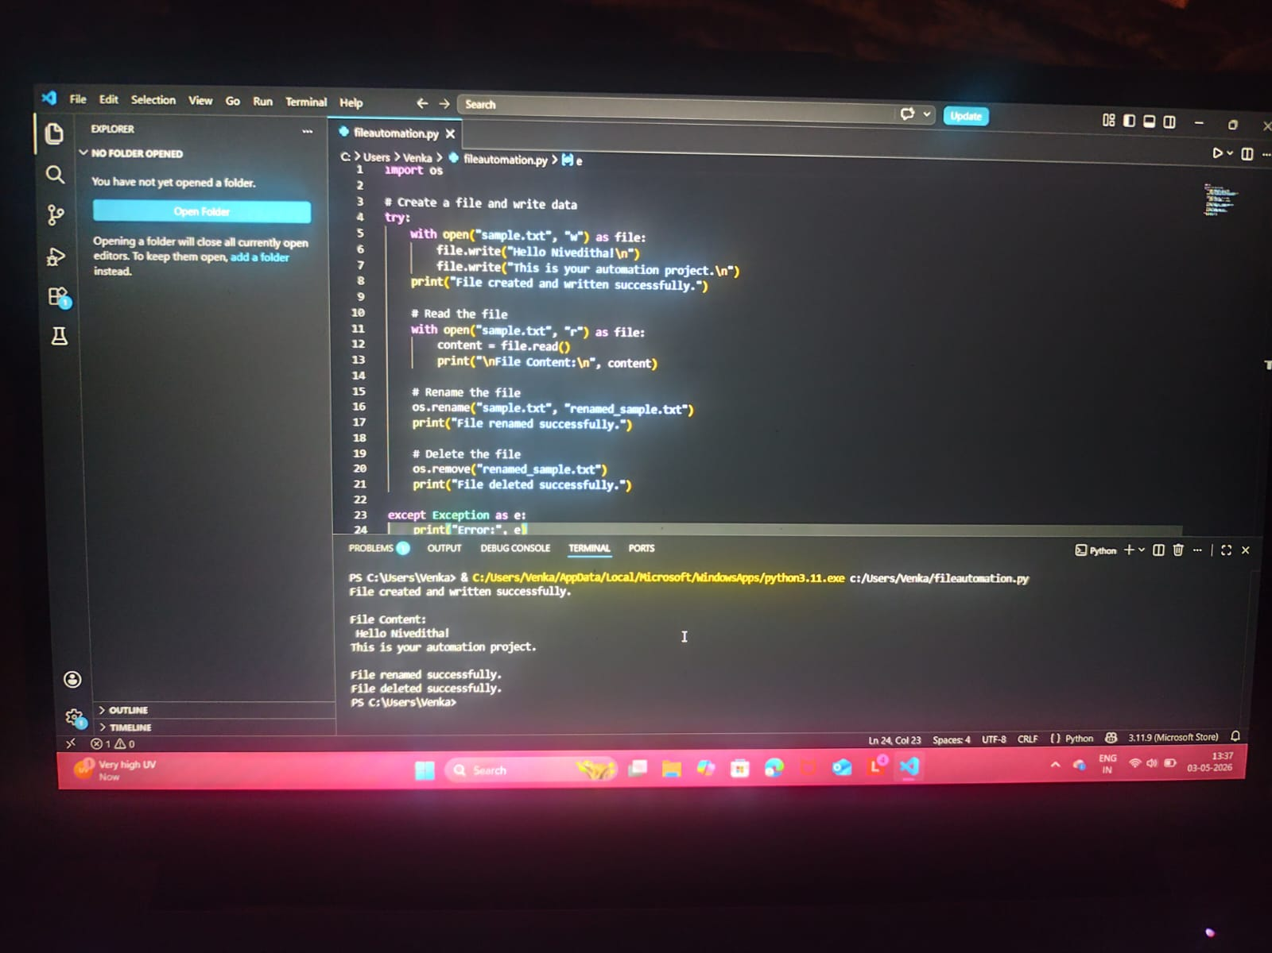
Output
The program successfully:
- Created a file
- Displayed content
- Renamed and deleted the file

